*Trần Phúc Thành - 20194846*

**RESULT OF RUNNING THE SCANNER PROJECT WITH EXAMPLE2.KPL**

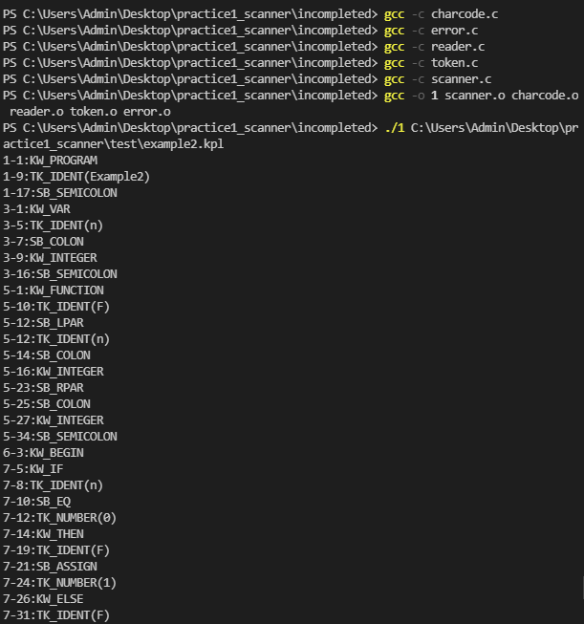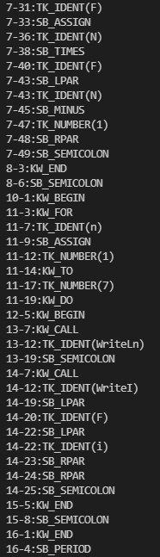

**RESULT OF RUNNING THE SCANNER PROJECT WITH EXAMPLE2.KPL HAVING ERROR ERM_INVALIDSYMBOL**

1. **Invalid Symbol _~_ (line 10 – column 7)**   
   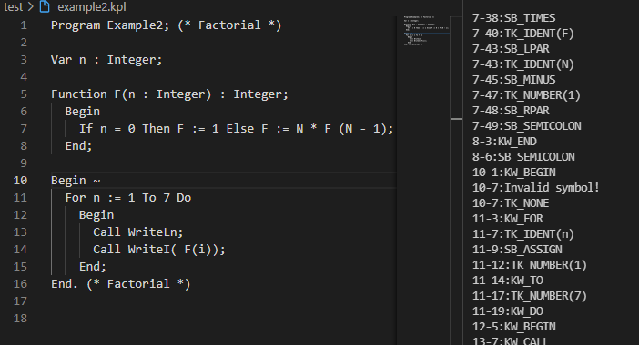
2. **Number too long (line 11 – column 17)**  
   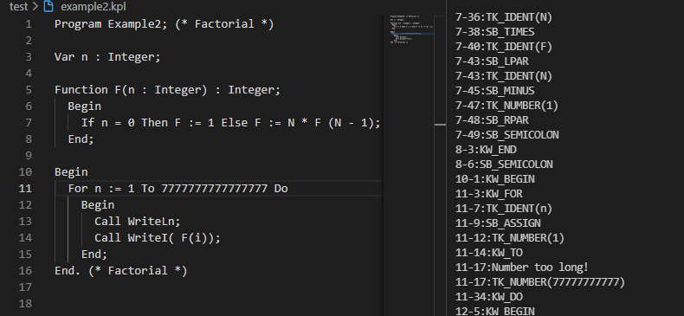
3. **Identification too long (line 3 – column 9)**  
   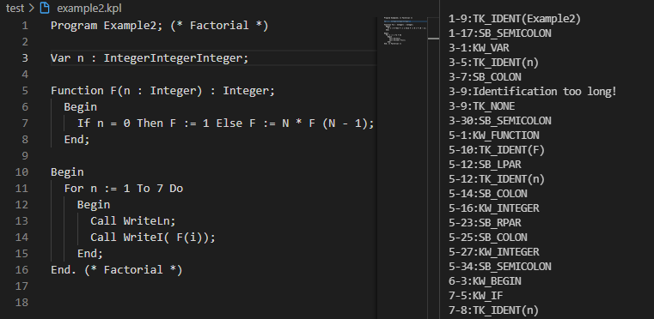
4. **End of comment expected (last line)**  
   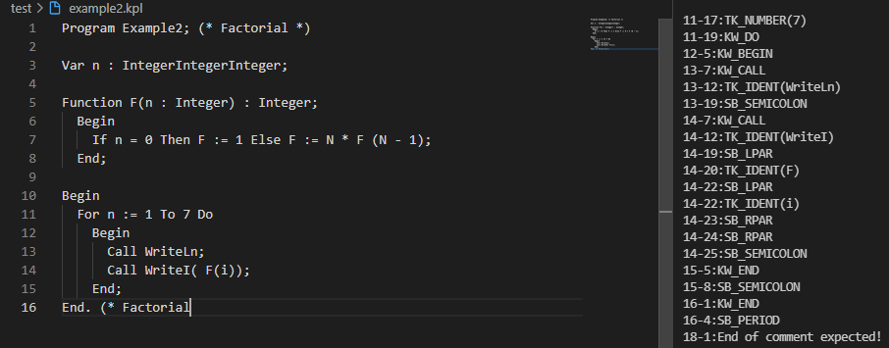
5. **Invalid character constant (line 15- column 7)**  
   